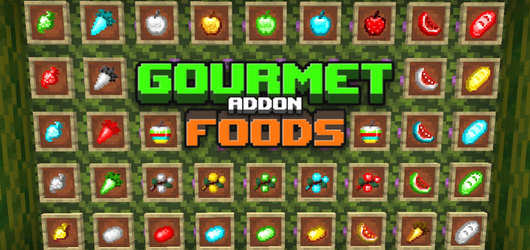
Welcome to my food addon for minecraft, in the first version of it you will have 33 new additional foods and each one with its functionality. I'm sure it will help you survive.
As you can see on the cover, the foods are the current ones in the game but this time crafted with ores, similar to the golden apple.
These are the foods added so far:

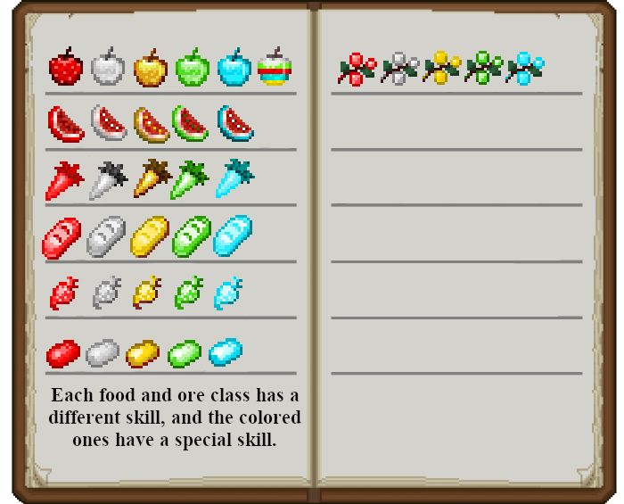

Food crafts are the same as golden apples.

About the foods:

apples: regeneration = 20 seconds;
Watermelon: regeneration = 17 seconds;
Sweet Berries: regeneration = 15 seconds;
Bread: regeneration = 12 seconds;
Potato: regeneration = 10 seconds;
Carrots and Beets: regeneration = 8 seconds.

About the ores:

Gold: Absorption; fire resistance;
Diamond: Absorption; Water Breathing;
Iron: Resistance; Speed;
Emerald: Hero of the village; Invisibility; Strength;
Redstone: Jump Booster; Slow Falling;

On the apple of all ores, its effects are of less time than the others and it has: invisibility; jump booster; fire resistance; Aquatic breathing; Resistance.

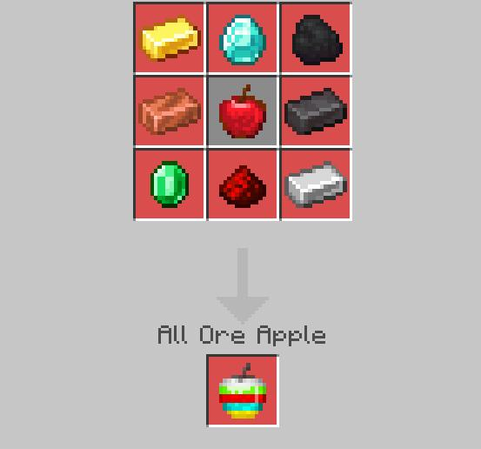

Nutrition varies depending on the rarity of the food and the ore. Saturation too.

